Type the title of your paper
First Author ^{1,*}, Second Author ², Third Author ³
¹ First affiliation institution, First affiliation address, City, Country, e-mail
² Second affiliation institution, Second affiliation address, City, Country, e-mail

ARTICLE INFO |  | ABSTRACT
Article history:  Received 15th Jun 2021  Accepted 16th Aug 2021  Available online 29th Nov 2021 |  | Abstract should be limited to 1 paragraph (250 words) and convey the main points of the paper, outline the results and conclusions, and explain the significance of the results. Any inessential abbreviations (those personally invented, in particular), any formulas, references to bibliography, figures and/or tables are inadmissible in the abstract.  Font - Cambria; Style: Italic; Size: 11  Paragraph - Alignment: Justified; Before: 6pt; After: 6pt; Line spacing: Exactly 11  Copyright © 2020 Hanoi University of Mining and Geology. All rights reserved.
Keywords:
Please provide 5 keywords separated with comma. (Font - Cambria; Style: Regular; Size: 10)

1. Preamble
Please read carrefully the instruction below when using this “Template” to not lose the required format of paper.
1/ Copy and Paste into the Template under format “Keep Text Only”.
2/ Use the tool Track Changes for any changes and amendements.
The manuscript should not exceed 8,000 words, including figures and tables; and must be saved in Microsoft Office (in .doc / .docx), with Custom size (21 cm x 27.6 cm), left and right margin 2.25 cm; top margin 2.2 cm, bottom margin 2.3 cm. Font - Cambria; Font size: 11. The page numbers in this template should not be changed.
_____________________
* Corresponding author
E - mail:
DOI:
The manuscript should be prepared with a tight layout, concise sentences; drawings and photos (if any) must be clear and of high quality. Table (if any) must be in text form according to the Template. The figures should be in PGN or JPG format with image quality of at least 300 dpi/pixcel. The figures are numbered and attached to the manuscript.
The manuscript should be clearly defined all of the following sections: Title of the paper, Name of author/authors and address/addresses, Abstract, Keywords, Introduction, Theoretical basis and research methods, Content of articles (with drawings, pictures, tables (if any) and notes related to them), Results, Discussion, Conclusions, Acknowledgments (if any), List of references, Appendices (if any).
Reference information from other scientific works must be cited as references. Citations in the paper should be listed in the bibliography, placed at the end of the paper. Documents in the reference list must be strictly represented in the following order: author name, journal title/book title, chapter/article title, publication year, publication number, page number (page to page). In addition, the DOI number of the reference documents (if any) should also be included.
For scientific papers, figures, pictures and tables are an important part of illustrating the text and therefore their position should be arranged logically after the relevant text.

2. Using editing software
Review reading, editing process are done on electronic manuscripts. Therefore, the manuscript of the paper must be prepared using a popular software so that the editorial board members and reviewers can easily read, edit and reformat it, with less technical errors. For the convenience of editing, the software Microsoft Words (Font Cambria, Style Regular, Size 11) is required.

3. The structure of the paper
The paper should be divided into separate sections according to the respective content, each section is numbered clearly, in the order of 1, 2, 3, ... If each section consists of sub-sections, they are numbered in turns 1.1 (followed by 1.1.1, 1.1.2, ...), 1.2, and so on.
The Abstract and Keywords section are not numbered separately.

3.1. Introduction
The Introduction provides a brief summary of the research state of the research fields in the country and in the world, hightlights the topicality of the issue, and questioning.

3.2. Data and research methods
Outline the research method, research facilities, contents of the research done.
Provide sufficient information on the basis of research methods. It is necessary to fully cite the published methods used in the research of the paper but there is no need to re-describe them.
3.2.1. Unit of measure
Authors are asked to use international standardized and unit system (SI). If other measurement systems are used, their correspondence should be converted to SI units.
3.2.2. Mathematical formulas
Use the Equation Editor to edit the math formulas which are numbered to the right of the margin. Parameters in formulas must be clearly defined and showed in italics.
E.g.
$$R=\frac{l}{σS}=\frac{2πr}{σπ{\left(\frac{D}{2}\right)}^{2}{10}^{-3}}\frac{N}{384}$$ | $$(1)$$
In which: D - diameter of wire (mm); σ - the resistivity of the winding materials (S / m); r - the mean radius of the coil (mm); N - number of turns per roll.
For simple formulas, write the formula on a plain line and use a slash (/) for small fractions (E.g. X / Y). For more complex formulas, use the formula template in the Microsoft Words software. Formulas are numbered according to the order in which they appear in the paper (if used for reference or cited in the paper).
3.2.3. Figure (example below)
Figures, immediately following explanations in the paper, are placed at the top or bottom of each page. If there are many parts in a picture, number a, b, c, d, ... with note for each part. Figures are numbered according to the order in which they appear in the paper, together with a note/caption for the figure; Use the usual cardinal numbers for numbering. Clarify the size of the figures to match 1, 1.5 or 2 columns of the page.

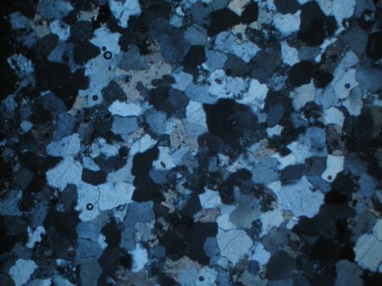
Figure 1. The titles and captions are placed at the end of each figure.
All drawings/figures made with specialized software must be converted to image files (with required resolution, color, and color composition) in one of the following formats:
- EPS (or PDF): vector graphics.
- TIFF (or JPG): color image or gray background, with a minimum resolution of 300 dpi.
- TIFF (or JPG): line / line drawing, with a resolution of at least 1000 dpi.
- TIFF (or JPG): composite drawings including images and lines, using a minimum resolution of 500 dpi.
Images are numbered as in manuscript and sent as the attached file (ZIP / RAZ).
Note: The figures of Viet Nam map must be clearly noted on the Spratly islands and Paracel islands of Viet Nam.
• Do not submit low resolution drawings/pictures (GIF, BMP, PICT, WPG,...);
• Do not submit the drawings/pictures with large dimensions.
• If there are photo or color pictures, the author should submit a file of black and white version of all the color images/ illustrations.
Figure caption
Each figure must have a clear title and illustrative explanation with the appropriate type and font size to be readable in both print and digital versions. The explanations in the figure should be brief, all symbols and abbreviations in the figure must be clearly explained.
The titles and captions of figures are numbered in the order in which they appear in the paper.
In the manuscript of the paper, the titles and captions are placed at the end of each figure.

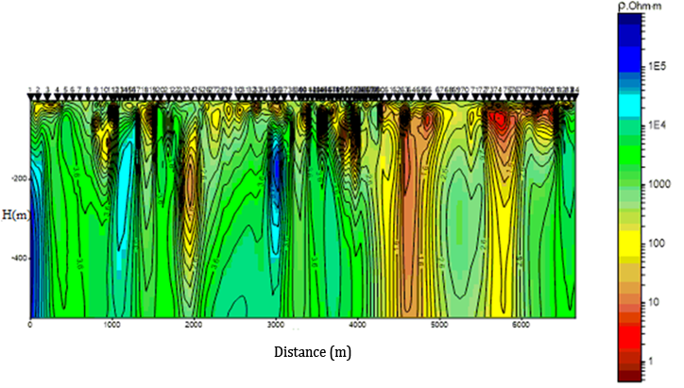
Figure 2. Images reach resolution of 300 dpi or more and attached as compressed files (RAR/ZIP).

3.2.4. Table
Tables are placed immediately after the corresponding text, at the top or bottom of the page. Each table must always have a column of listed numbers.

Table 1. Title is placed at the top of the table.
TT | District | Area (km²)
1 | Kon Tum | 3.932,3
2 | Gia Lai | 8.783,2
3 | Đăk Lắc | 8.456,7
4 | Tổng | 33.794,1
If tables are used, they should be clearly formatted with appropriate font sizes. Table title is placed at the top of the table. Tables must be numbered, contain clear instructions, and ensure that they can be edited.

3.3. Content and results achieved
The content of the paper must be presented scientifically and concisely. The results of the research must be clearly described.

3.4. Discussion
This section should consider the important contributions of the research results, not repeat the results. The Discussion and Conclusion sections should be brief. Avoid citing and discussing too much about your published works.

3.5. Conclusion
Highlight the main contributory outcomes of the paper. Propose future research or suggest the application of research results.
This section should be briefly and can be independent and not numbered.

Acknowledgments
This is written in a separate paragraph at the end of the article, after the Conclusion. This section is intended to thank the individuals and organizations that assisted the author(s) in the research and writing the paper.

Contribution of authors
The corresdponding authors indicate the contribution of each author that is quantified by a percentage. All authors are legally responsible for such information.

References
The tool End note is recommended for references and citations.
List of references is arranged alphabetically based on the name of the editor or main author (if there are 2 or more authors). For each reference, the names of all authors participating in the article should be fully listed. The full title of the journal must be clearly visible. Some examples following illustrate the format:
Paper published in journal
Name of author(s), (year of publication). Title of the paper. Journal title (italic) volume (issue), from page ... to page ....
Hoxha, D., Homand, F., (2000). Microstructural approach in damage modelling. Mechanics of Materials 32(3), 377-387.
Lê Văn Dũng, Cao Đình Triều, (2012). Biểu hiện hoạt động của thạch quyển ở miền tây bắc Bộ. Tạp chí khoa học trái đất 16, 111-123.
Presentation at conferences
Name of author(s), (year of publication). Title of the article. Name of Conference (italic), Date and place of conference, place of publication, from page…. to page….
Hoxha, D., Homand, F., (2008). Microstructural approach in damage. The 2nd international conference on dynamics and control. January 23-26, Norfolk, Japan, 377-387.
Nguyễn Văn B, (2016). Một số giải pháp trong khai thác. Tuyển tập hội nghị toàn quốc lần thứ 20 về Mỏ và Khoa học Trái đất. 13-16/4, Hạ Long, Quảng Ninh, Việt Nam, 123-134.
Book
Name of author(s), editor (if any), (publication year). Full title (including sub-title, if any). Volumes (if any), reissues (if any). Publisher, (Country), archive (italic), Number of pages referenced or number of pages of the book.
Newman, B., (2015). Theory of elasticity and applications. Springer. New York, 438 pages.
Trần Văn Hùng, (2015). Địa chất đại cương. Tập 2. Nhà xuất bản Khoa học - Kỹ thuật. Hà Nội, 230 trang.
Master and Doctoral Thesis and Dissertation
Author's name, year of publication. Thesis name. Thesis type (italic). Place of publication, and number of pages referenced.
Trần Văn Khanh, (2017). Nâng cao chất lượng giáo dục đại học. Luận án Tiến Sỹ, Đại học Mỏ - Địa chất. Hà Nội, 313 trang.
Adhiri, P. H., (1990). Physio-morphological responses of upland rice to shade. PhD Dissertation, University of the Philippines Los Banos, Philippines, 123 page.

